# Trainings log Application

## Prototype screenshots

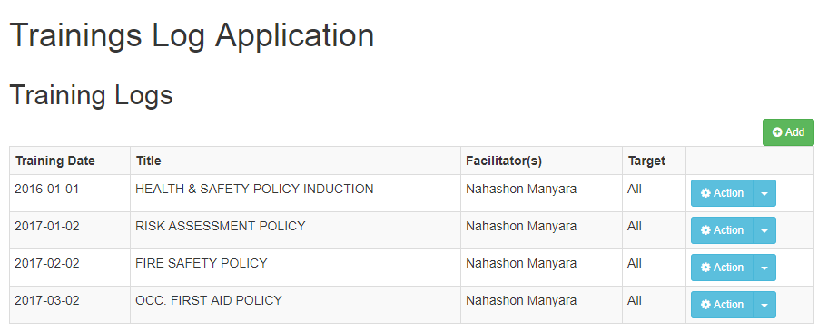

Figure : Listing of logged Trainings

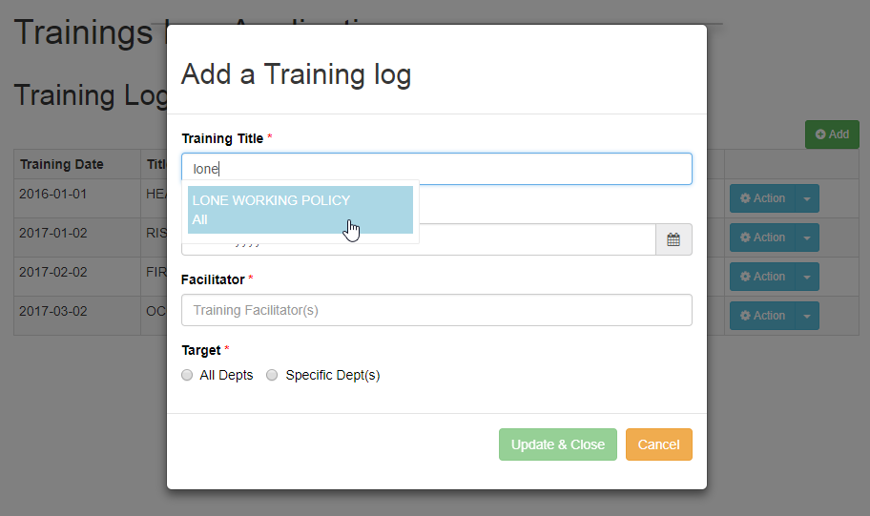

Figure : Log a new training

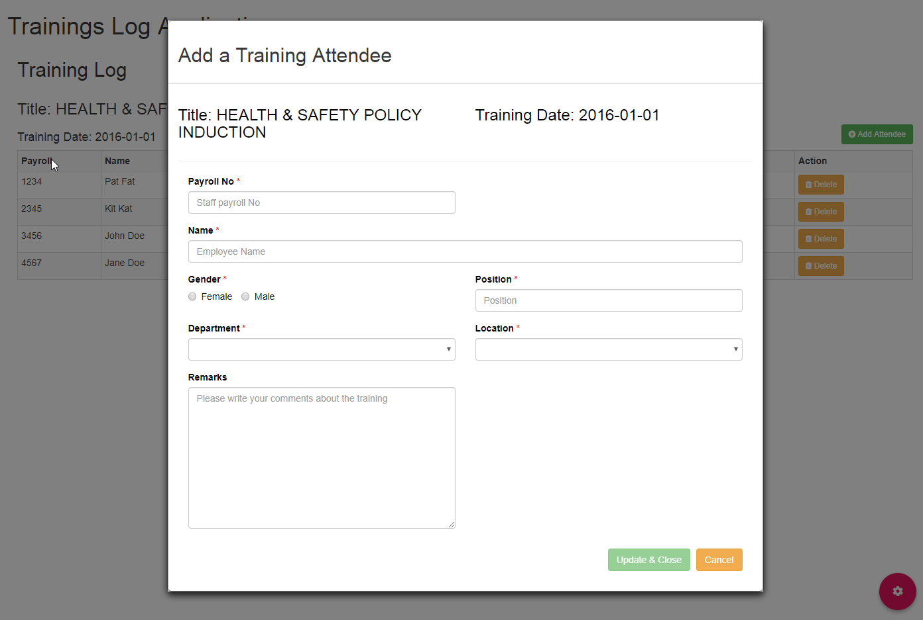

Figure : Add a training attendee

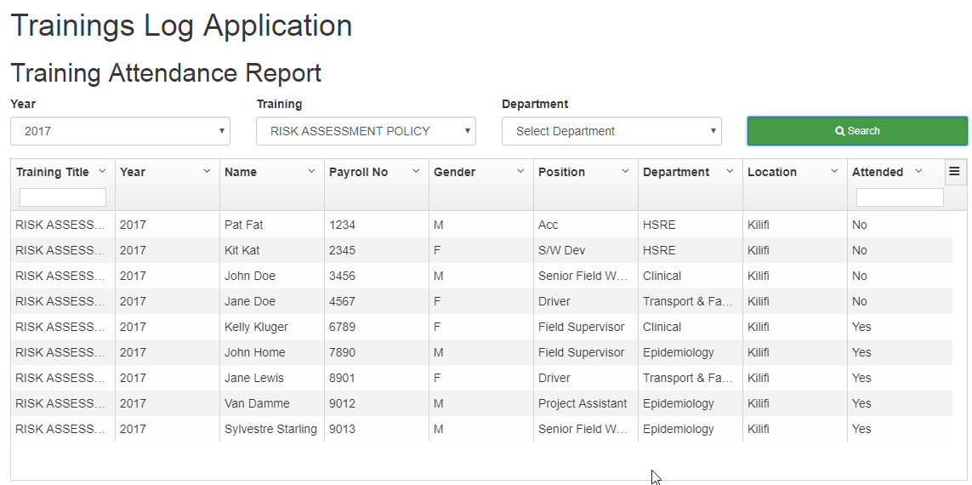

Figure : Training Attendance Report

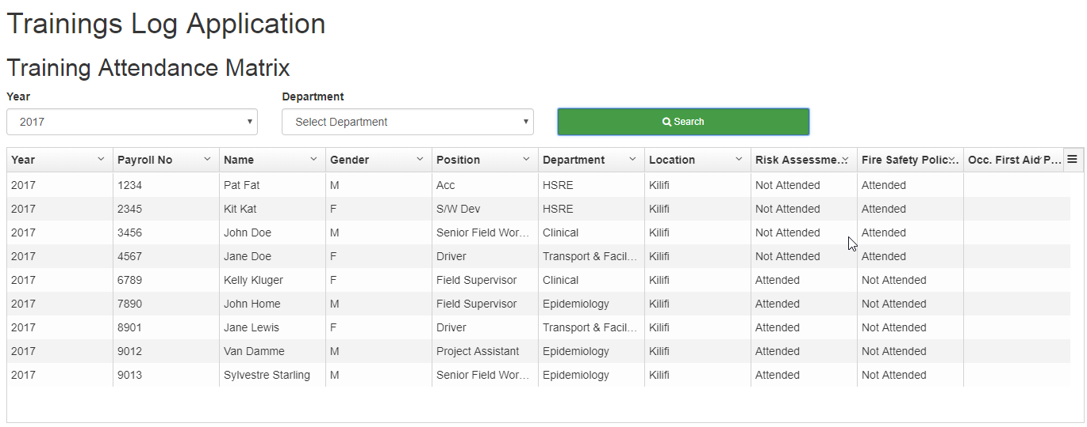

Figure : Compliance Matrix

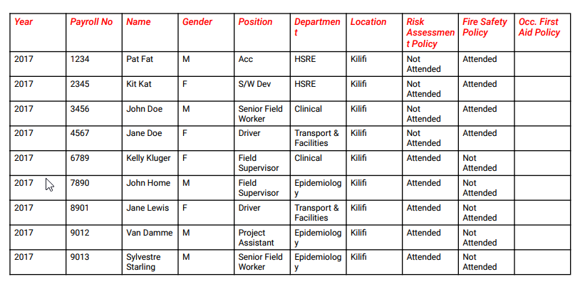

Figure :Compliance Matrix - PDF export